Environmental heterogeneity and the spatial distribution of Amazonia's trees

Jennifer P. Auler, Alexandre, A. Oliveira, Alberto Vicentini, Alvaro Duque, Renato Valencia, Dairon Cárdenas

Poster and abstract presented to Ecology Across Borders 2021
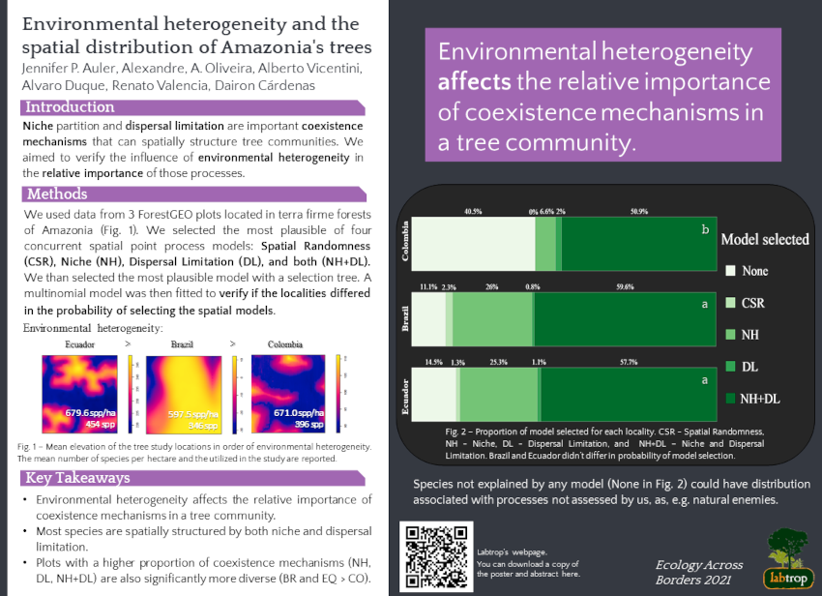

Abstract
Environmental heterogeneity and the spatial distribution of Amazonia's trees
Niche and dispersal limitation are important coexistence mechanisms that can spatially structure tree communities. We aimed to verify the influence of environmental heterogeneity in the relative importance of those processes. We used data from ForestGEO plots with different environmental heterogeneity (Colombia-CO < Brazil-BR < Ecuador-EQ). We selected the most plausible of four concurrent spatial models: Randomness (CSR), Niche (NH), Dispersal Limitation (DL), and both (NH+DL). BR e EQ didn't diverge in the probability of model selection, having 85,6% and 83% of niche models selected (NH and NH+DL), while in CO only 57,5% were observed. The proportion of no model selected was four times higher in CO than in BR and EQ. We attribute these differences to CO's lesser environmental heterogeneity and conclude that it influences the relative importance of processes. Plots with a higher proportion of coexistence mechanisms are also significantly more diverse (BR and EQ > CO).
Download poster and abstract here

