Luisa Truffi
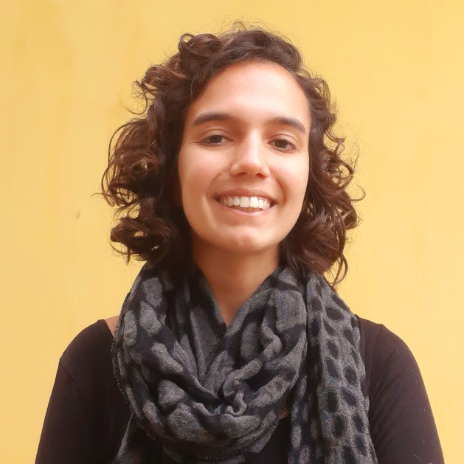
I started my path as Tropical Forest Ecologist as a field technician in the Cardoso Island Permanent Plot census in 2019. This experience inspired my curiosity about the forest structure and dynamics. Later I graduated in 2020 as a Bachelor in Biology at the University of São Paulo. As an undergraduate student I worked on a project that investigated the Phylogenetic structure of the White-sand Forest and Slope Forest in the Atlantic rainforest. I’m currently a Masters student at the Federal University of São Paulo under the supervision of Camila Castanho. In my Masters I am investigating if phylogenetic relationships determine the outcome of plant-plant interaction in coastal plains.
My main interests are Coastal Tropical Forests Ecology and Phylogenetics.
ATBC 2022 poster

